Volunteer application form | 

Personal details
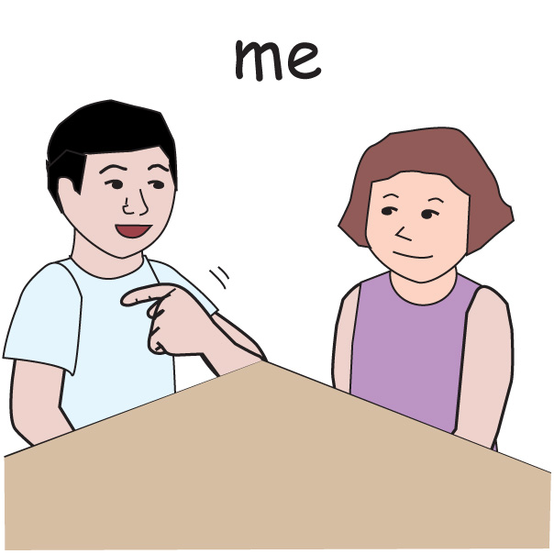

Name: 
Telephone: 

Email Address: 

Address: 

Reasonable adjustments
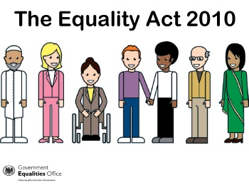



Do you have lived experience of disability or long-term conditions?

Are there any adjustments you think we need to know about?

Relevant training or qualifications
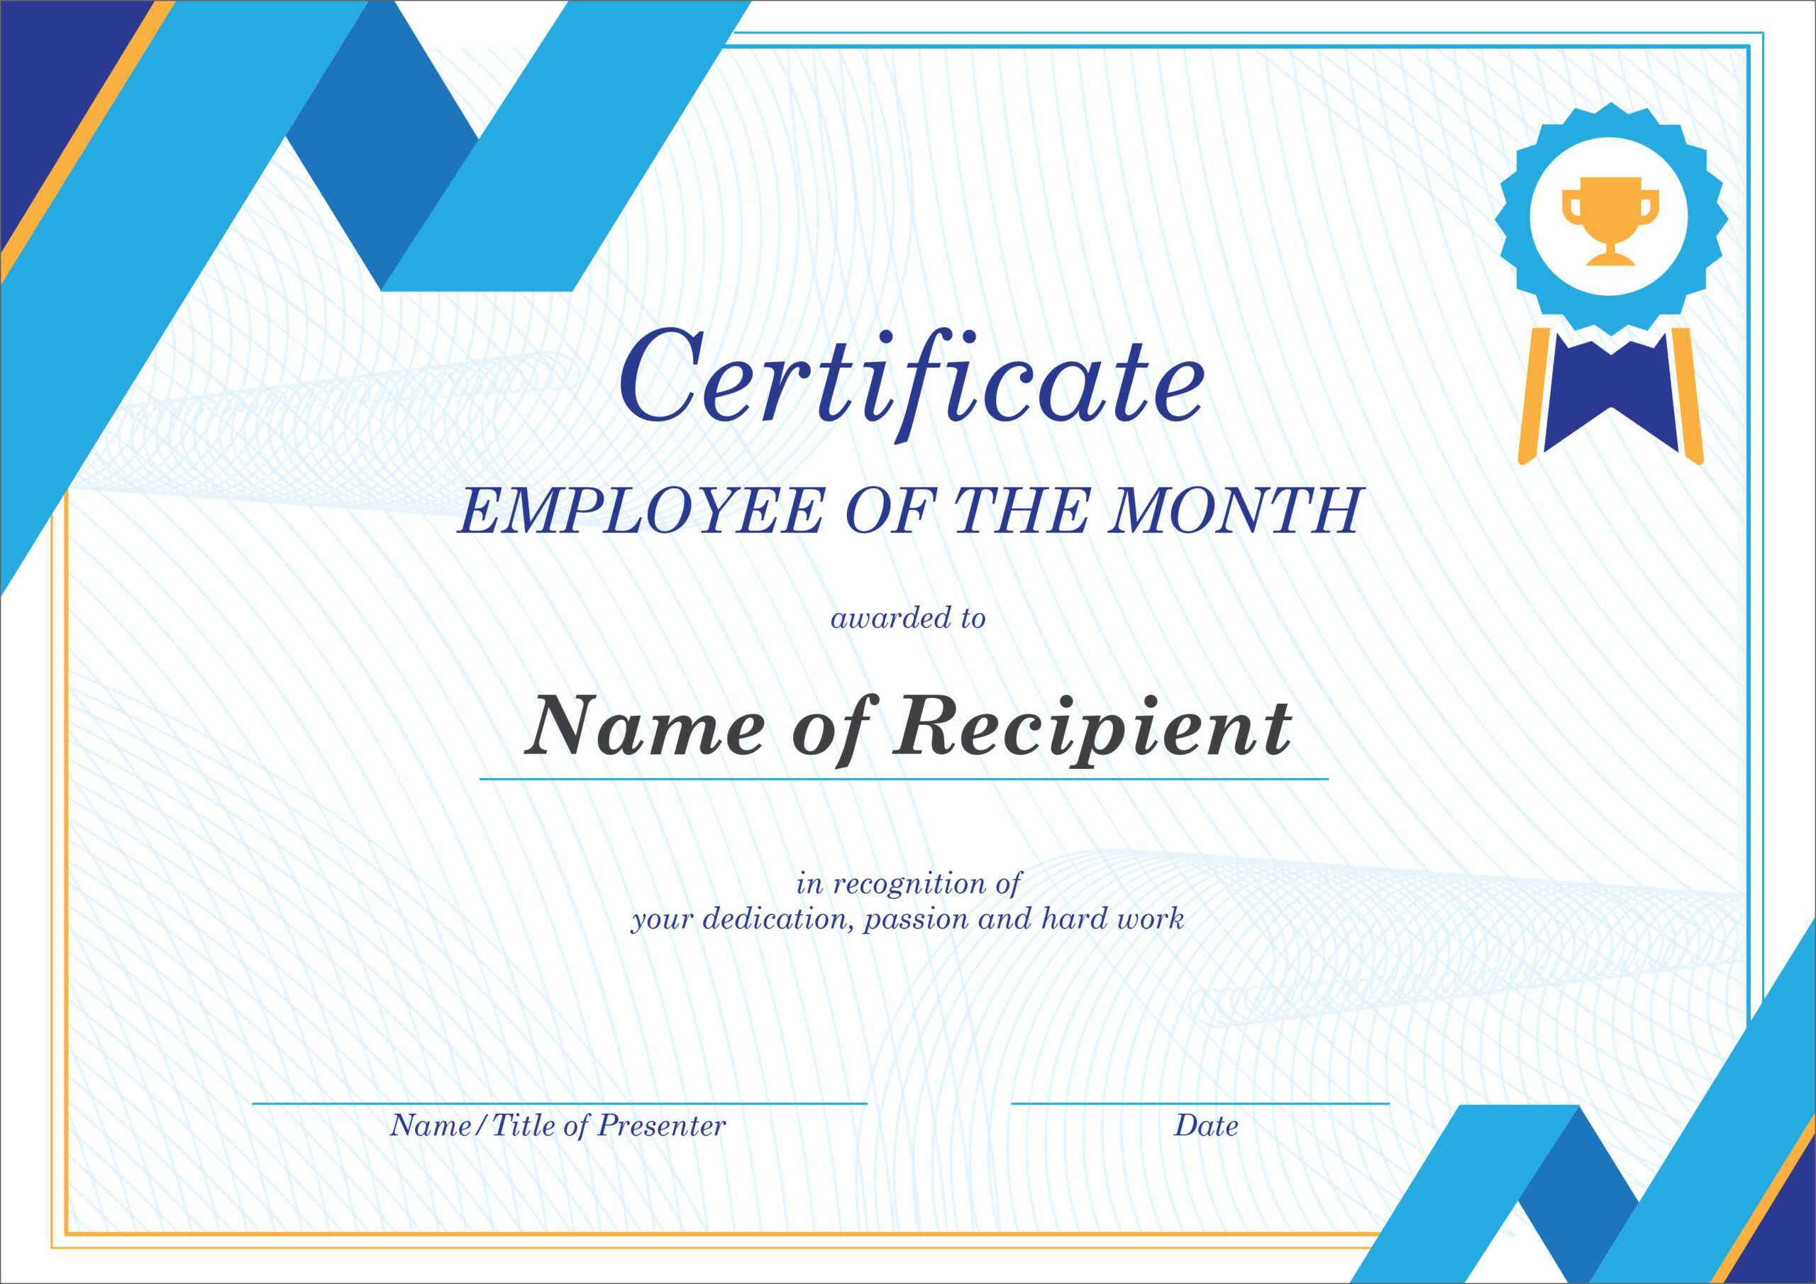

Title of training or qualification | Date completed

Work experience or other volunteer experience



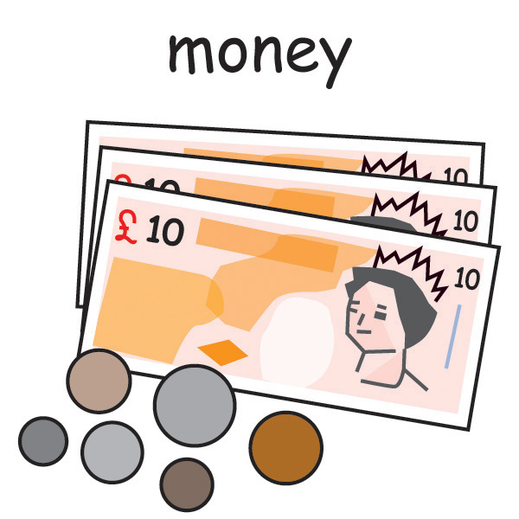

What do you do/did you do at work or volunteering?

Supporting Information


Please tell us anything you think we should know about you
Please tell is about why you want to volunteer
Please tell us about your interests

Days you are available

What days are you available to work?

Transport

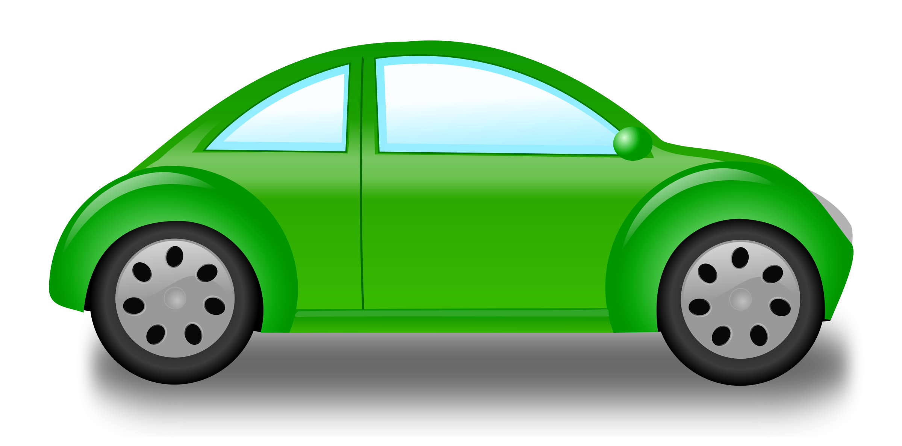
Do you have access to a car/transport for volunteering?


Do you need assistance with transport?

Relations

+

+
Are you related to / or have a personal relationship with any employee of Disability Positive?
If you are related to someone please state their name

Criminal Convictions


Do you have any criminal convictions?

If you have a conviction, please give details

Should you identify have a criminal conviction, this will be discussed in confidence at interview.

Enhanced Disclosure and Barring Scheme

You may need to complete a Police check if you volunteer with us and will be in contact with children and adults

References

Referee 1 |  | Referee 2
Name: |  | Name:
Job Title: |  | Job Title:
Organisation: |  | Organisation:
Address: |  | Address:
Postcode: |  | Postcode:
Phone No: |  | Phone No:
Email: |  | Email:

Declaration

In accordance with the Data Protection Act 1998, and the General Data Protection Regulations 2018, the information provided on this form will be disclosed to those who need to see it.
In you are unsuccessful the form will be destroyed after 6 months, in line with our HR Privacy notice.

Please sign
I confirm I have read and understood the privacy notice.
I confirm the information provided is accurate to the best of my knowledge.

Your name or ID Date:
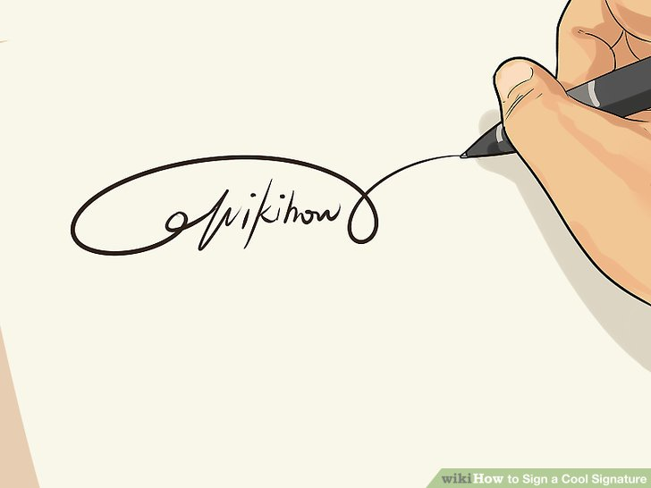

Please return this form to cate@disabilitypositive.org

