Abuse or Aggression to Staff Incident/Near-Miss Report Form  <Name> | 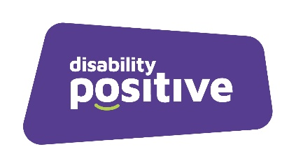
Staff should complete this form as fully as possible for the risk of abuse/aggression (i.e. physical abuse, aggression, verbal abuse, or racial abuse, intentional damage to personal property) to be managed more effectively and reduced in the future.

Location of Incident |  | Date and Time
Details of Incident
Please describe the incident in as much detail as possible; including:
- events leading up to it
- what work was being carried out the time,
- what happened as it escalated,
- were there any contributing factors,
- whether a weapon was involved,
- who else was present
- what the outcome was.

Type of abuse
Details of the Offender (if known)
Client I.D (if relevant):
Name:
Address:
Age:
Is the offender known to be involved in previous incidents? Yes / No
If Yes, Give brief details:

Details of any Witnesses
Name:
Address:
Contact No.:

Name:
Address:
Contact No.:

Preventative Measures
Had any measures been taken to try and prevent an incident of this type occurring or if no measures were taken beforehand, in your view could action now be taken?

Signed
(Staff member):
Job Title:
Date:
Return this form to your manager within 48 hours after the incident/near miss

Health & Safety Executive (HSE) Tel: 0845 300 99 23
http://www.hse.gov.uk/riddor/index.htm

